***MPCA LAB 2***

***Name: Rithvik Rajesh Matta***

***SRN: PES2UG23CS485***

***Class: 4H***

1. Q1: Write an ALP using ARM7TDMI to perform to multiplication of 16X24 without using MUL instructions.(Hint: barrel shifter instructions.)

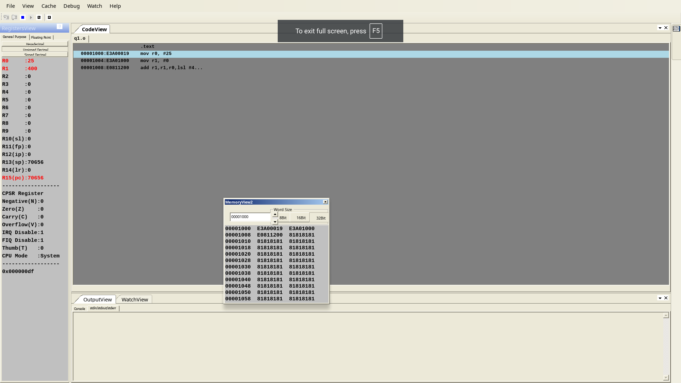

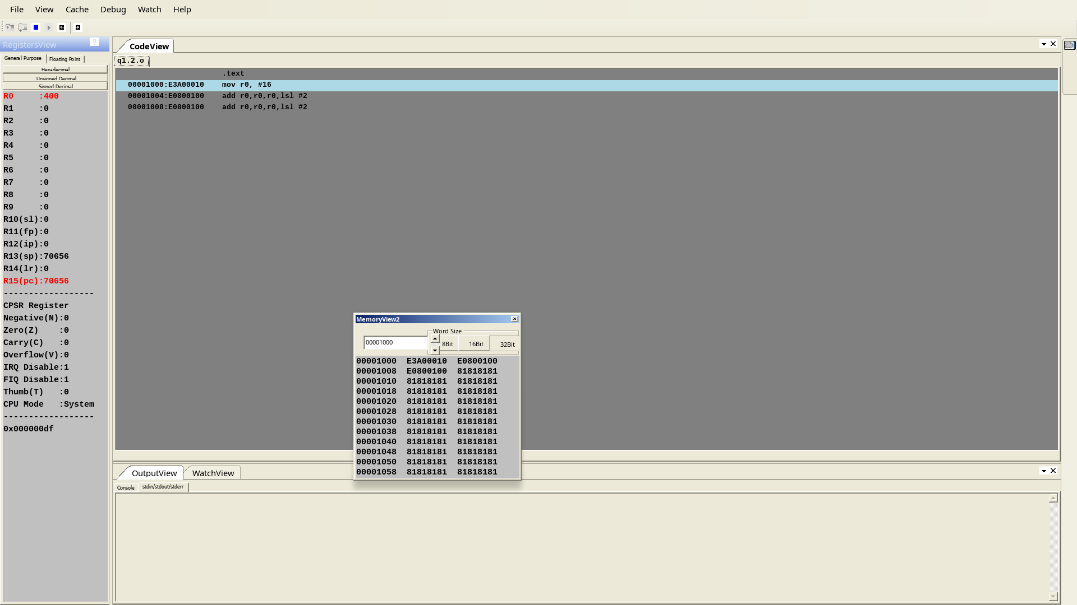

Q2: 2. Write an ALP using ARM7TDMI to add only even numbers stored in memory location for a given set of numbers and store the sum in the memory location.

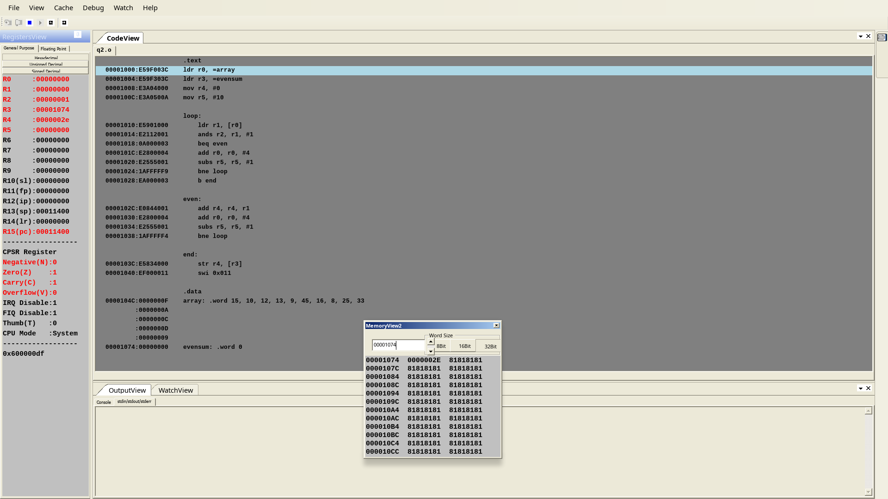

Q3: 3. Write a ALP using ARMTDMI-ISA to store odd and even numbers in separate memory locations starting from LOCA and LOCB respectively

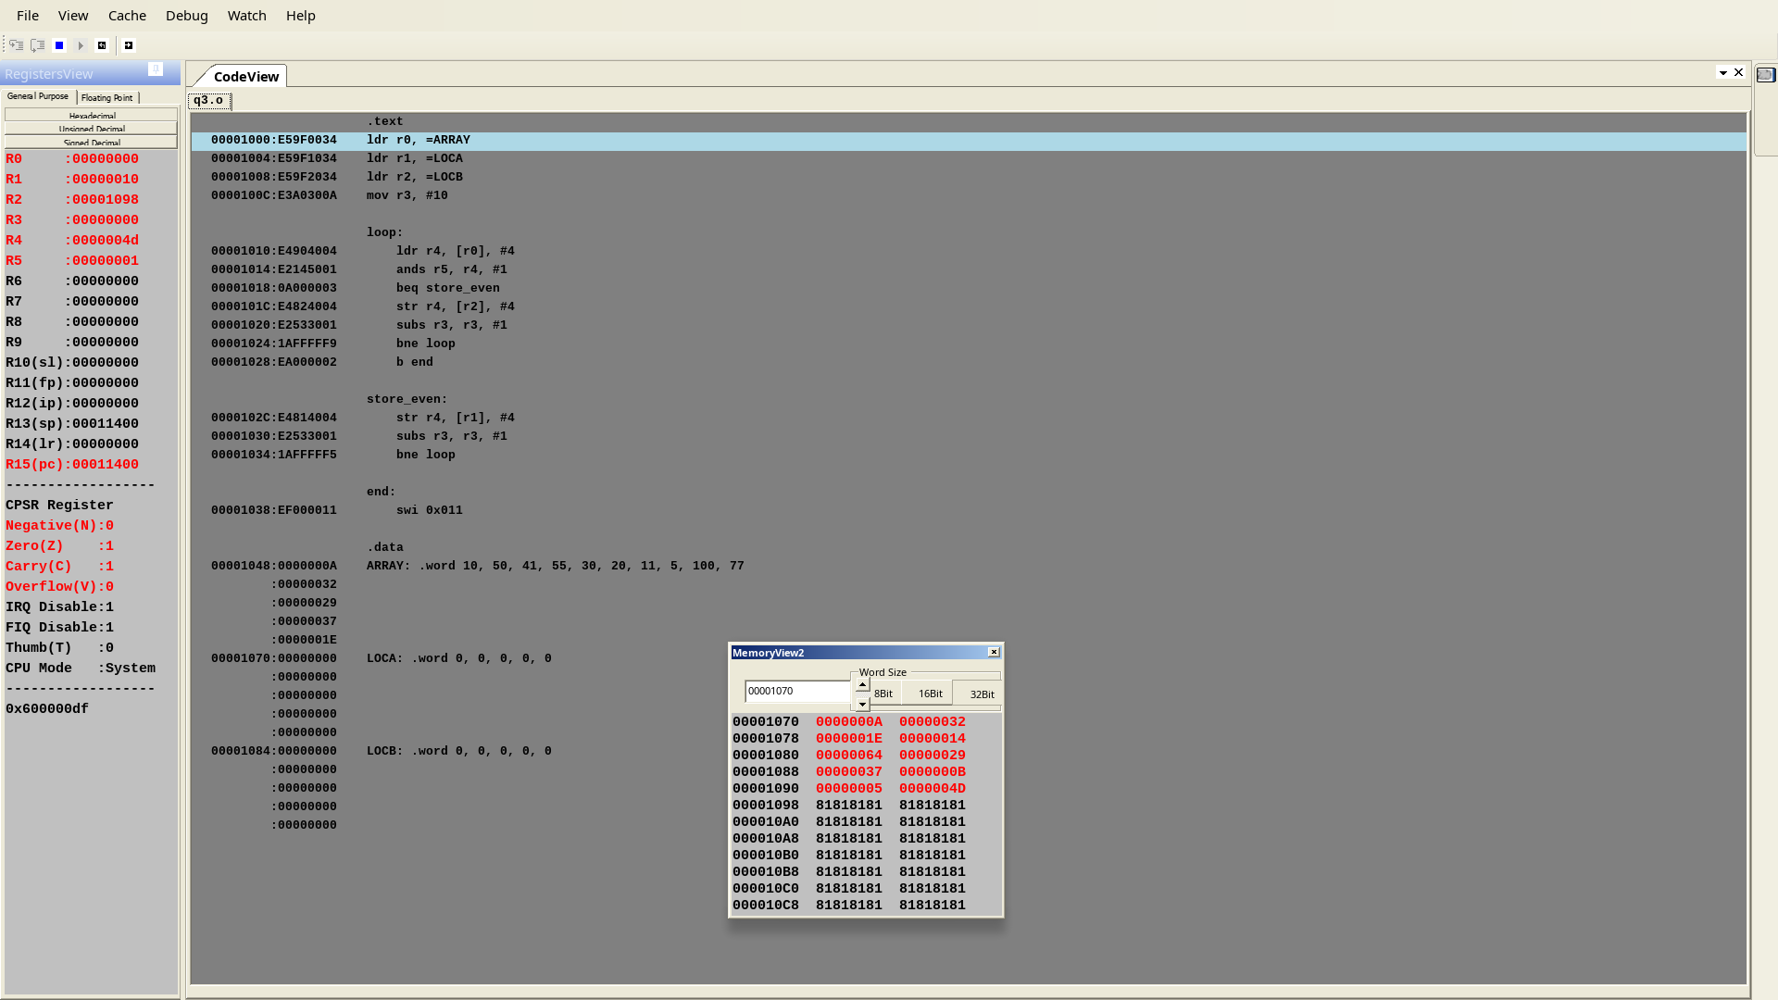

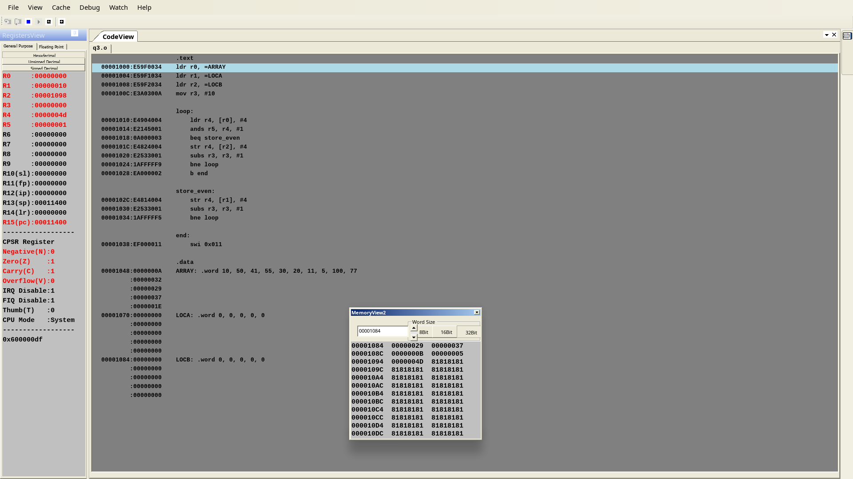

Q4: 4. Write an ALP using ARM7TDMI to find the largest number from a given set of numbers:

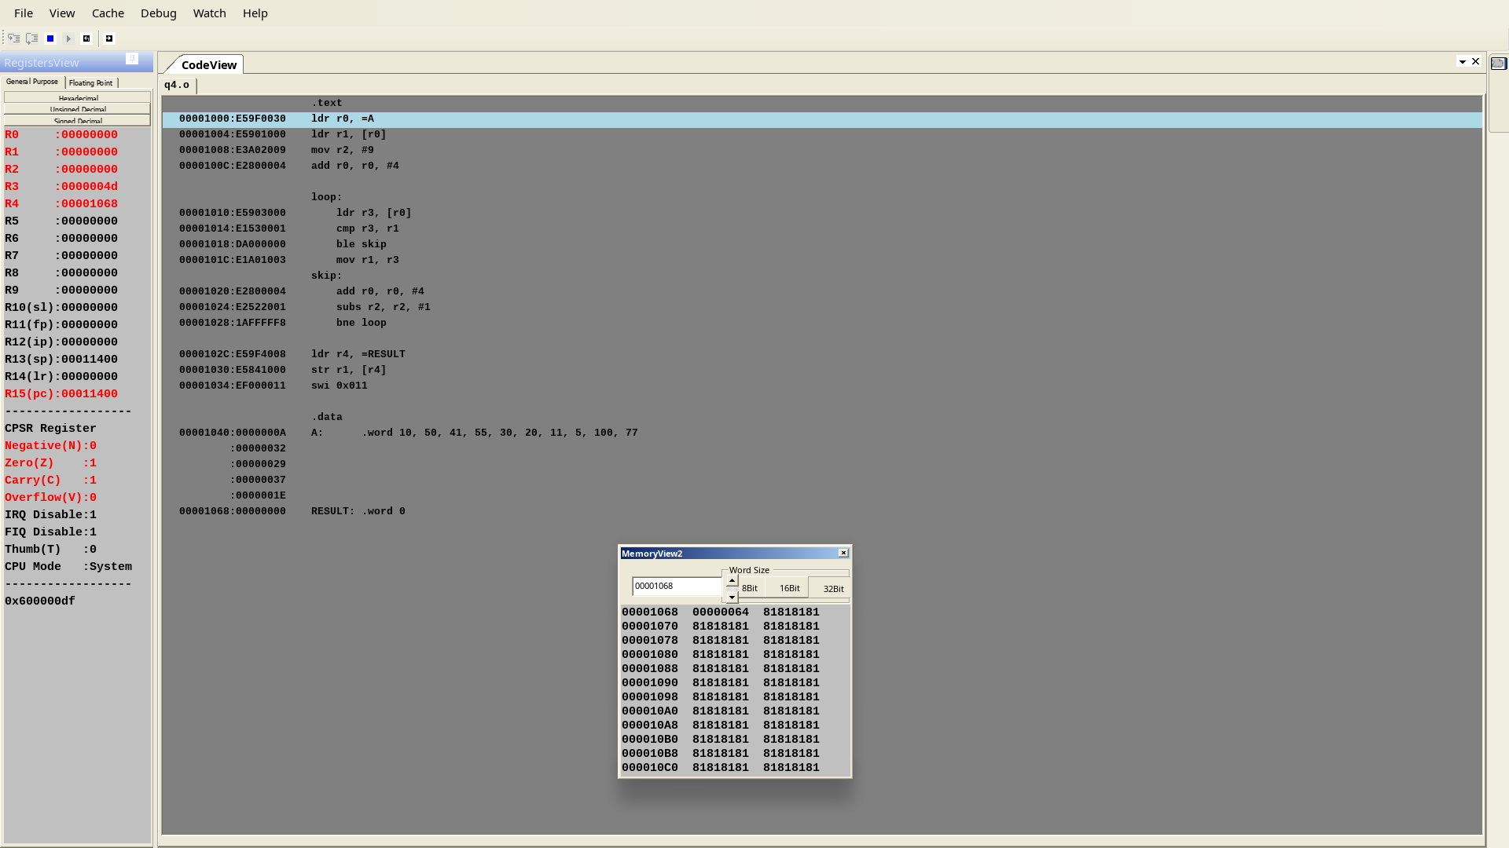

Q5: 1.Write an ALP using ARM7TDMI to find whether the given number is even parity.

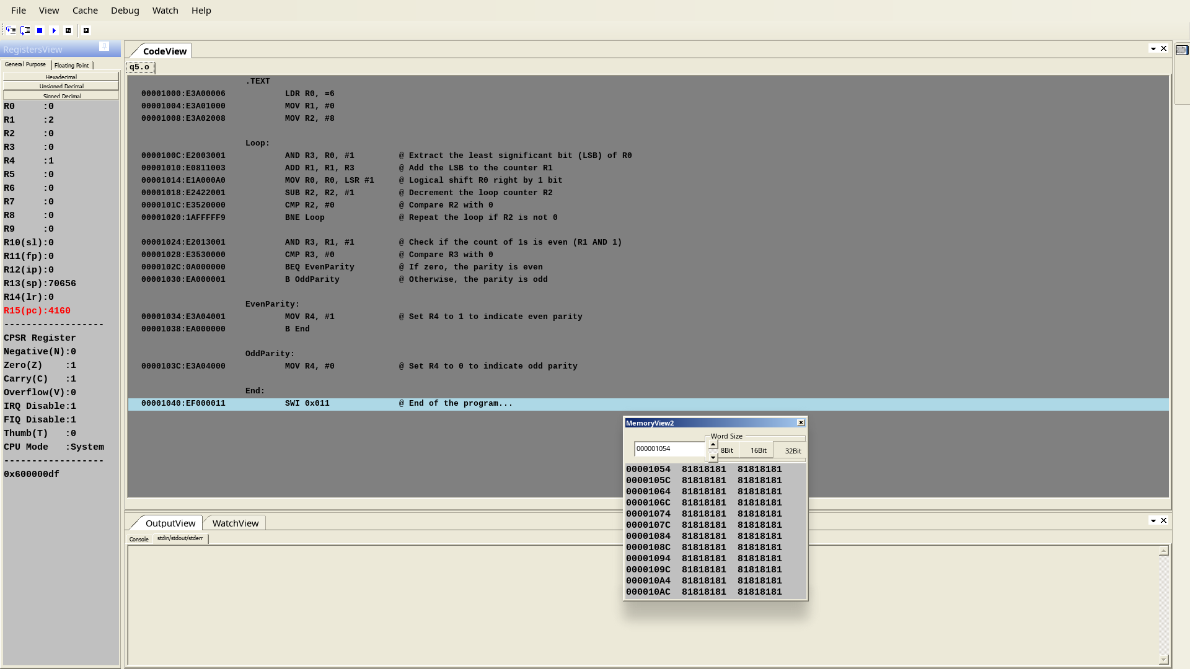

Q6: 2. Write an ALP using ARM7TDMI to multiplication of 38X72 without using MUL instructions.

